RoamReady — Master Build Plan
All locked UX changes, sequenced as paste-ready task blocks
Prepared by Cindy (UX) · May 21, 2026

How to use this document
This consolidates five hand-off docs into one ordered build plan. It is written to be fed to Claude one block at a time: paste a single task block (its text plus its mockup image) into Claude, ask Claude to produce the code, then apply it with Claude Code. Work the blocks top to bottom — they are ordered safest-first, with the changes that touch AI generation and data shape deliberately last.
Each block is self-contained and follows the same shape so it drops cleanly into a prompt:
- Context + goal: the page/component it touches and the goal in one line.
- Mockup: the visual target to build toward.
- Build: the specific changes to make.
- Guardrails: what NOT to touch, and what to confirm against existing code before building (this is where rebuilding shipped work goes wrong).
- Done when: the check that tells you the block is complete.
Callouts: amber “Confirm against existing code” = verify before building so you only build the gap; red “Bug” = something currently broken; gray “Note” = context or a recorded decision.

Shared design system (applies to every block)
Pages have no color of their own — color lives in status pills and small accents. Locked palette: gold #FDEFD9 / #8A5A0E (Planning), RV-blue #E0F0F4 / #134756 (Active), pine #DCE5D5 / #2F4030 (Booked/Completed). Gold #BA7517 is reserved for primary CTAs and is budgeted (~6–8 gold moments per page max). The D1 sunset gradient is only ever a 4px nav strip. Dimensions are in feet to one decimal. Use real characters / HTML entities, never raw escape codes.

Build order at a glance
Phase | Blocks | Risk
0 · Warm-up | 1. Nav highlight bug | Trivial
1 · Navigation frame | 2. Home swap 3. Merged Dashboard 4. Resources nav 5. Reservations tab | Medium
2 · Profile & onboarding | 6. Remove emergency contact 7. Second-vehicle section 8. Trip-setup vehicle 9. Travel Style | Medium
3 · Itinerary visuals | 10. Trip at a Glance 11. Drive day card 12. Stay day card (visual) | Low
4 · Behavior | 13. Estimate → actual rate | Behavior
5 · AI / data (last) | 14. Memberships per-stop flow 15. Stay-day Model B + trip wipe | Highest

PHASE 0 — WARM-UP

Block 1 · Nav highlight bug
Context: The top navigation component.
Goal: Make the active nav item highlight (turn blue) consistently on every page, including the one that currently doesn’t.

Build
Currently, clicking a nav heading turns the active section blue — except one item (the Plan page) never gets the active state even when you’re on it. The active check is almost certainly an exact-route match: items like /dashboard match exactly, but the Plan item points at /trips/new while the highlight logic compares a different/parent path, so it never registers. Switch that item to the same match pattern the others use (or a “starts-with” match).

Guardrails
- Do not touch: isolated to the nav component; don’t refactor routing elsewhere.
DONE WHEN: Every nav item shows the blue active state when its route is active, with no exceptions.

PHASE 1 — NAVIGATION FRAME
Build these four together-ish: they interlock and touch the same nav component and route table. Final top nav becomes: Home · Dashboard · Resources · Profile.

Block 2 · Home swap — AI canvas becomes the landing page
Context: Routing + the current Plan page (SessionPage) + the current Home (dashboard).
Goal: Make the AI planning canvas the landing page; move the trip-list to the Dashboard (Block 3). Retire the “Plan” nav label.
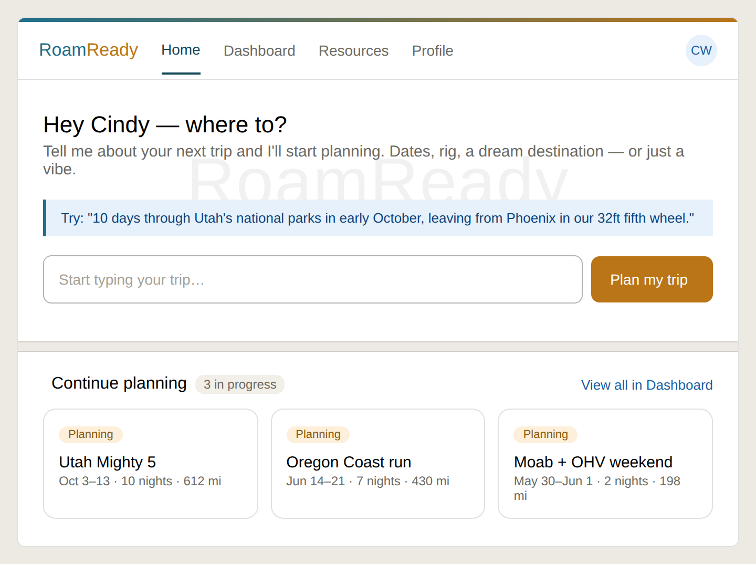
New Home: the AI canvas is the hero; a “Continue planning” strip of active trips sits lower, below the watermark, visually separated, with a “View all in Dashboard” link.

Build
- AI canvas as hero: Home is the existing AI canvas (greeting, optional structured form, example callout, chat input) — the current SessionPage content, now serving as Home.
- Continue planning strip: below the canvas, beneath the RoamReady watermark, add a “Continue planning” strip showing active trips as compact cards (status pill, name, dates/nights/miles), a labeled header with an “X in progress” count, and a “View all in Dashboard →” link. It reads as a preview, not the full list.
- Empty state: a new user with no trips sees essentially just the canvas (empty strip collapses).

Guardrails
DONE WHEN: Logging in lands on the AI canvas; no trip is created until the user prompts; returning users see their active trips in the strip below.

Block 3 · Merged Dashboard — Dashboard + Trips become one page
Context: DashboardPage + TripsPage + inbound links to both.
Goal: Merge the two near-identical trip-list surfaces into one Dashboard at /dashboard with status filter tabs.
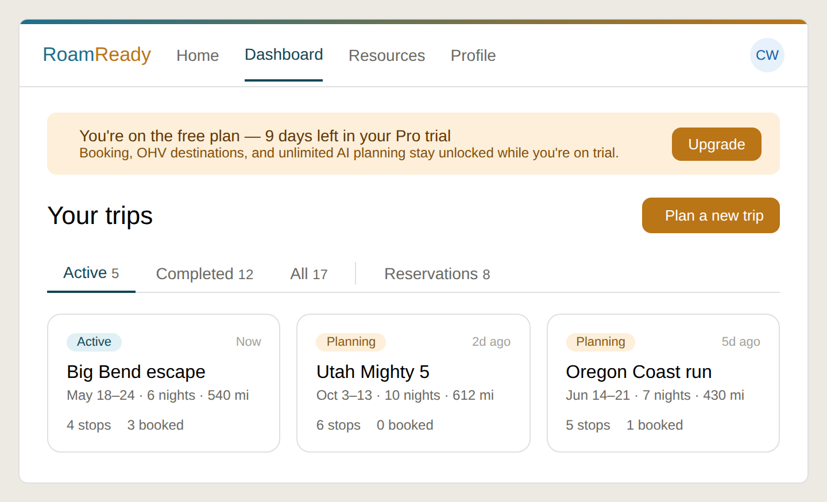
Merged Dashboard: trial banner on top, gold “Plan a new trip” CTA (routes to Home), status tabs Active / Completed / All (Active default), trip cards with locked status pills and a “2d ago” timestamp.

Build
- Trial banner: stays at the top — it’s the main place free users learn the trial is ticking. Warm gold styling (an upsell nudge, not an error).
- Header CTA: page title + gold “Plan a new trip” CTA that routes to Home (the canvas), looping the two pages together.
- Status tabs: Active / Completed / All, defaulting to Active. Active = old Dashboard behavior; Completed + All = the archive Trips provided. Counts beside each label.
- Trip cards: reuse locked status-pill vocabulary (gold Planning, blue Active, pine Completed); add a small “2d ago” timestamp.

Guardrails
Nothing structural breaks — it’s a “repoint inbound links + retire the dead page” job. The risk is leaving one link un-repointed. Repoint at the merged Dashboard: login/OAuth post-sign-in redirect; Reservations links pointing to /trips; the trip map “back to trips” link; nav items.
DONE WHEN: /dashboard shows one page with working Active/Completed/All tabs; /trips redirects to it; no nav button leads to a dead page.

Block 4 · Resources nav — a home for the Quick Actions
Context: Top nav + the four Quick Action cards currently at the bottom of Home.
Goal: Add a Resources item to the top nav holding the app-level destinations; retire the Quick Action cards from Home.

Build
- Resources hub: new top-nav item (peer to Home, Dashboard, Profile) opening a hub that links to: Maintenance tracker, Resources along route, Product roadmap, and — fixing the orphaned-page problem — the OHV and Van destination pages.
- Quick Actions retired: the four Quick Action cards (Maintenance, Bookings, Resources, Roadmap) are removed from Home. Maintenance/Resources/Roadmap move into the hub; Bookings points at the Reservations surface (now a Dashboard tab — Block 5), since it’s trip workflow, not a resource.
Why a nav item and not a Dashboard tab: the Dashboard tabs are all filters of your trips. A Resources tab would be a different kind of thing, breaking that model. Resources is app-level, so it belongs in the nav.

Guardrails
DONE WHEN: A Resources (or Tools) nav item opens a hub linking all five destinations; Home no longer shows Quick Action cards.

Block 5 · Reservations — from top-nav item to Dashboard tab
Context: The cross-trip /reservations page + the Dashboard tab row from Block 3.
Goal: Fold the cross-trip reservations roll-up in as a fourth Dashboard tab; remove Reservations from the top nav.
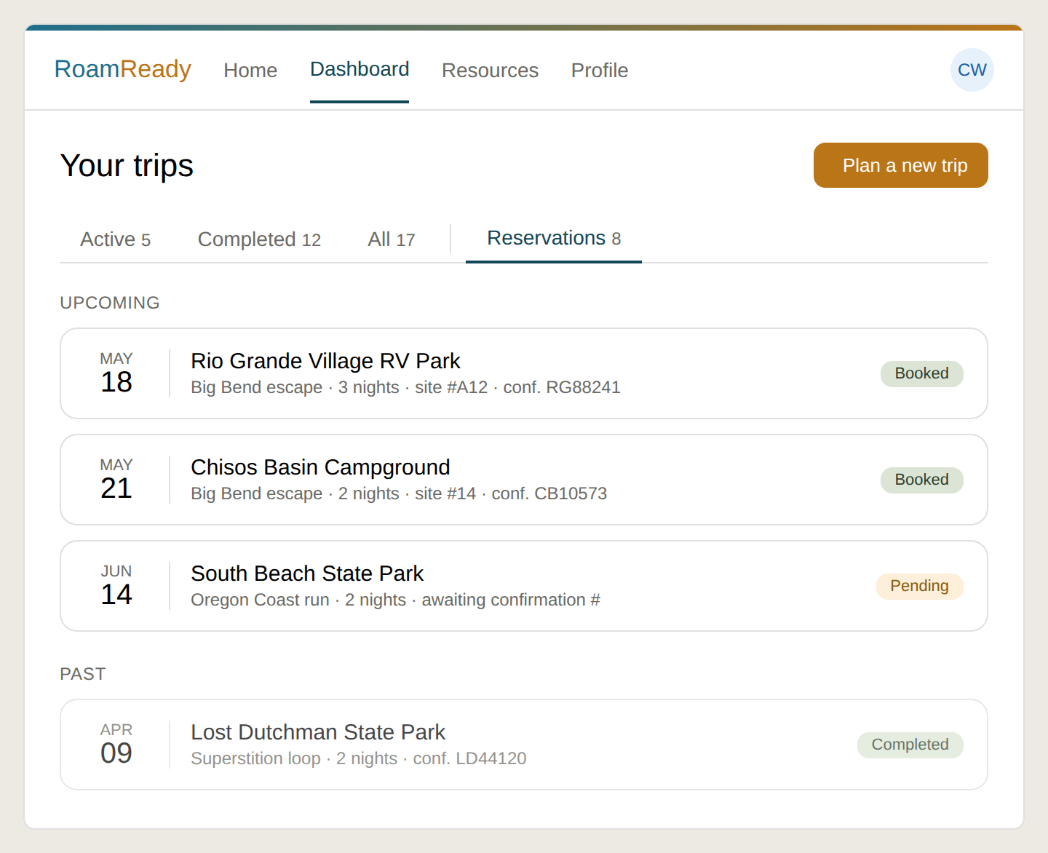
Reservations as a Dashboard tab: a cross-trip booking list grouped Upcoming/Past by date, each row tagged with its trip and carrying a status pill, set apart from the trip-status tabs by a divider + calendar icon.

Build
- New tab: a “Reservations” tab joins the Active/Completed/All row, set apart with a thin divider + small calendar icon so it reads as a different lens (bookings, not trip-status). Show a count.
- Tab content: tapping it swaps the trip-card grid for a cross-trip booking list grouped Upcoming / Past by date. Each row: date chip, campground, the trip it belongs to, nights, site #, confirmation #, status pill (pine Booked/Completed, gold Pending). Past rows dimmed.
- Drill-down: tapping a row drills into that trip’s booking page (/trips/:id/booking) — the existing per-trip surface. This list is a roll-up into the existing drill-down, not a replacement. The per-trip /trips/:id/booking page is unaffected.

Guardrails
DONE WHEN: Top nav is Home · Dashboard · Resources · Profile; the Dashboard has a working Reservations tab showing bookings across all trips; /reservations redirects into it.

PHASE 2 — PROFILE & ONBOARDING
A self-contained corner of the app; doesn’t depend on the nav work above.

Block 6 · Profile — remove Emergency contact
Context: The Profile page + profile data model / save payload.
Goal: Remove the Emergency contact name and phone fields entirely.

Build
- Remove fields: remove the “Emergency contact name” and “Emergency contact phone” inputs from the Profile form, and the corresponding fields from the profile data model / save payload.
Rationale (recorded so the removal reads as deliberate): it’s write-only — only the account holder can open Profile, exactly the person who’d never look up their own emergency contact. No first responder, staff member, or companion can reach it when it would matter. It implies a safety capability the product doesn’t have. If wanted later, it only earns its place with a real delivery path (printed on the PDF itinerary, or tied to a future SOS/check-in feature).

Guardrails
DONE WHEN: Both inputs are gone from the form and the fields are removed from the save payload / model.

Block 7 · Rig / Vehicle — second-vehicle section
Context: The rig profile. Adds the towed/tow vehicle that the rig profile doesn’t currently capture.
Goal: Add one second-vehicle section that captures the towed OR tow vehicle, adapting its label, fields, and planning behavior from a stored towing-direction derived from rig type.
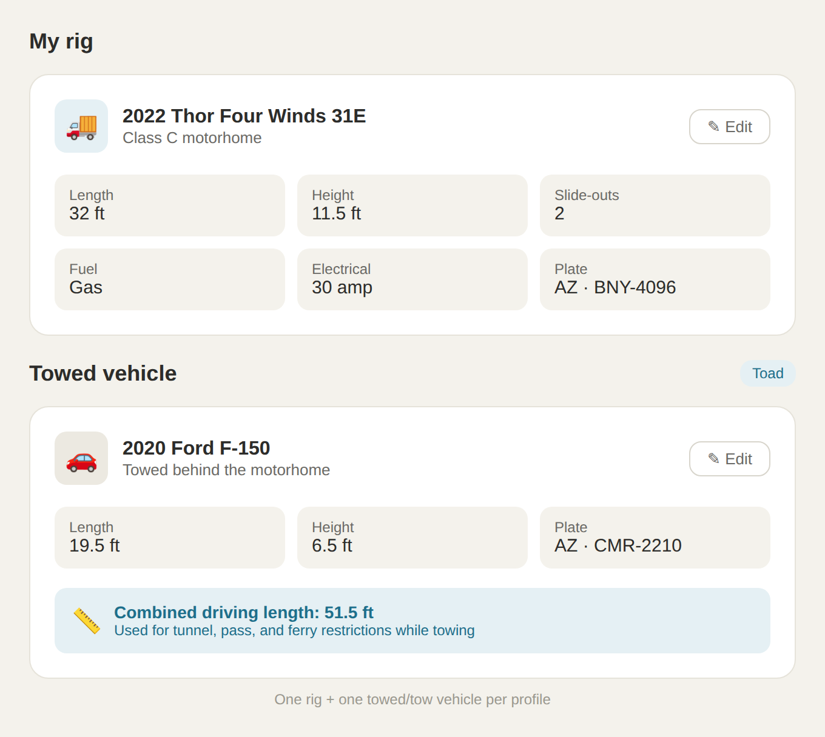
Motorhome + toad: car icon, “Toad” badge, blue combined-length strip used for tunnel/pass/ferry restrictions only (a toad is unhooked at camp, so it does not affect site fit).
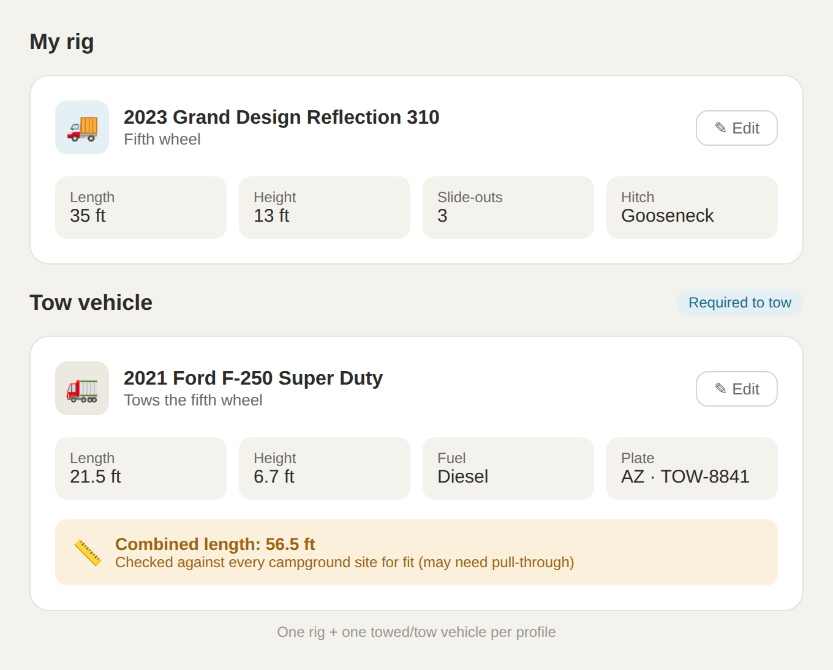
Fifth wheel + tow vehicle: truck icon, “Required to tow” badge, fuel field shown (diesel), amber combined-length strip checked against every campground site for fit. Direction is set automatically by rig type.

Build
- Direction derived from rig type: the user never picks it. Motorhome (Class A/B/C) → section reads “Towed vehicle,” badge “Toad,” optional, unhooked at camp. Fifth wheel / travel trailer → “Tow vehicle,” badge “Required to tow,” mandatory, stays attached.
- Fields: Year/Make/Model; Length (required, feeds combined length); Height (optional); License plate; Fuel type — show ONLY when direction = tow vehicle (diesel range/cost matters for a truck), hide for a toad.
- Combined length: computed (rig length + second-vehicle length, hitch gap ignored). Toad → used for driving restrictions only (tunnels/passes/ferries). Tow vehicle → a campground-fit factor (truck + trailer checked against every site, may need pull-through) AND driving restrictions.
- Visual: card mirrors the rig card (header icon + name + Edit, dimension grid, then combined-length strip). Toad = car icon + blue/info strip; tow vehicle = truck icon + amber/warning strip.
- Empty state: no second vehicle → show “+ Add a towed or tow vehicle” prompt, not a blank card. For a fifth wheel/travel trailer where a tow vehicle is logically required, show a gentle nudge.

Guardrails
- Scope limits (deliberate): one rig + one second vehicle per profile (double/triple-tow intentionally out of scope). Toy haulers: toys ride inside, so they are NOT a second vehicle — a toy hauler is a trailer rig with a tow vehicle; OHV/toy details stay in their own feature.
DONE WHEN: A rig profile shows a second-vehicle card whose label/badge/fields/strip-color follow rig type automatically, with the right empty state when none exists.

Block 8 · Trip setup — “bringing this vehicle?”
Context: The New trip flow. A profile says what you OWN; a trip says what you’re BRINGING.
Goal: During trip setup, ask whether the optional second vehicle is coming — but only when it’s genuinely optional.
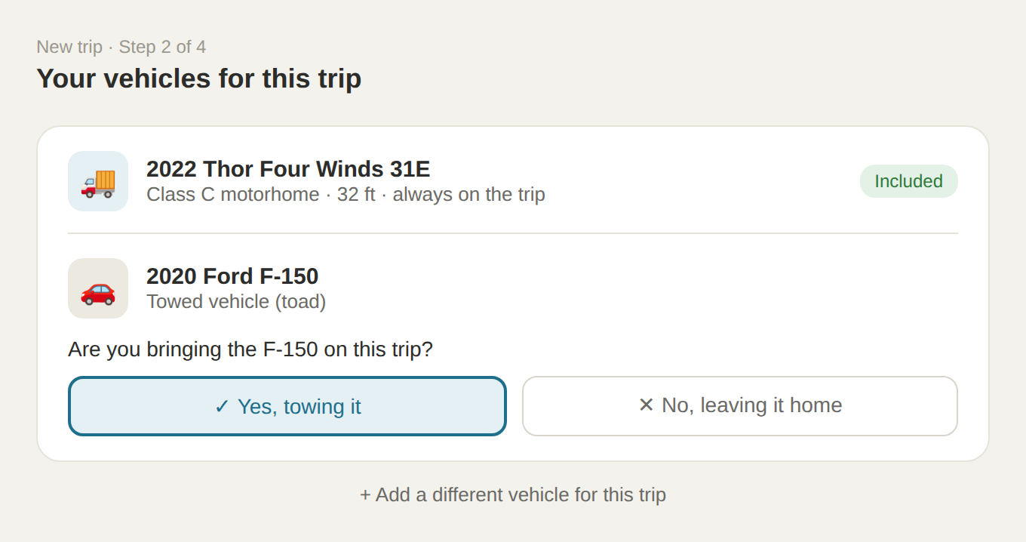
Trip-setup vehicle step. The rig shows as “Included” and is never a question; the optional toad gets a Yes/No. The bottom link adds an ad-hoc, non-saved vehicle for this trip.

Build
- New step: add a “Your vehicles for this trip” step to the New trip flow.
- Rig + tow vehicle: the rig always shows as “Included” (not a question). A required tow vehicle also shows “Included” — the rig can’t move without it.
- Toad question: only when the second vehicle is a toad (optional), ask “Are you bringing the [vehicle]?” with Yes / No.
- Ad-hoc vehicle: a “+ Add a different vehicle for this trip” link adds an ad-hoc vehicle that is NOT saved to the profile.

Guardrails
DONE WHEN: Starting a new trip with a motorhome+toad asks whether the toad is coming; a fifth-wheel rig auto-includes the tow vehicle with no question.

Block 9 · Travel Style — custom interests + collapse-to-clean
Context: The Travel Style step (interests chips). Campground Types is unchanged.
Goal: Let users add custom interests, and collapse unselected presets into a clean resting state.
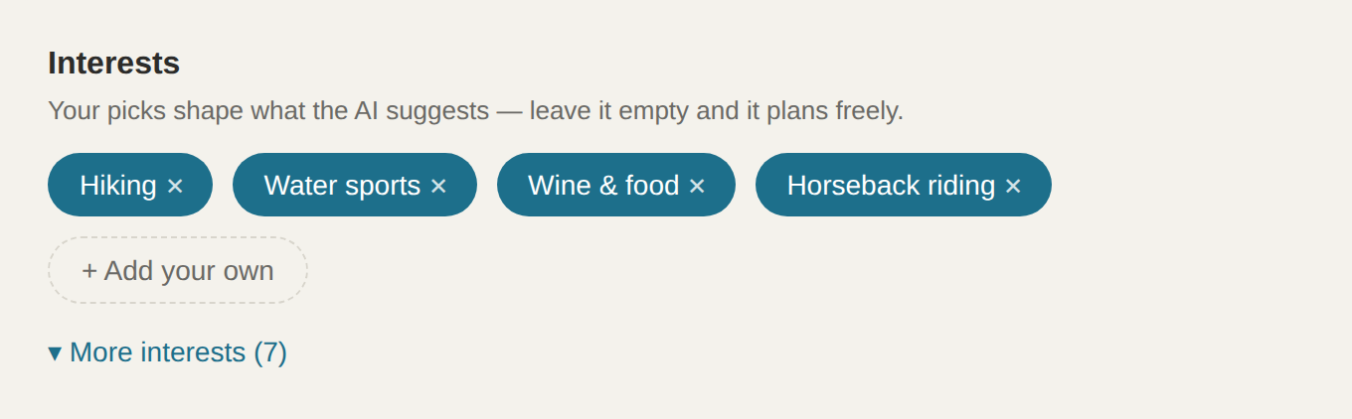
Travel Style interests, clean resting state: only selected + custom chips (“Horseback riding” is a custom add) plus “Add your own”; unselected presets collapse behind “More interests (N).”

Build
- Custom interests: a dashed-outline “+ Add your own” chip at the end of the flow reveals a single-line input (40-char limit) with an Add button. Custom interests become first-class chips inline with presets and are SAVED TO THE PROFILE (same interests array, user-authored), persisting across trips. The AI weights a custom interest the same as a preset.
- Collapse to clean (Option C): resting state shows only selected presets + custom chips + “Add your own.” Unselected presets collapse behind a “More interests (N)” toggle. A brand-new user with nothing selected sees the FULL preset list expanded (discovery); once they have picks it settles into the clean view.
- Chip removal: each selected chip has an ×. Deselecting a PRESET returns it to the “More interests” drawer (never destroyed). Removing a CUSTOM chip deletes it entirely.
- Campground Types: unchanged — a fixed 8-chip taxonomy, no “Add your own,” no collapse.

Guardrails
DONE WHEN: A user can add a custom interest that persists; unselected presets collapse behind “More interests (N)”; new users still see the full list; and interests/types are confirmed wired into the planning prompts.

PHASE 3 — ITINERARY VISUALS
Page-level visual polish on the trip itinerary (TripSummaryPage). Low risk. The header tint is the only colored element on each card; bodies stay white.

Block 10 · Trip at a Glance — slim it down
Context: The stats bar at the top of the itinerary page.
Goal: Keep all four stats (miles / nights / stops / est. total) but compress them into a slim single-line strip.
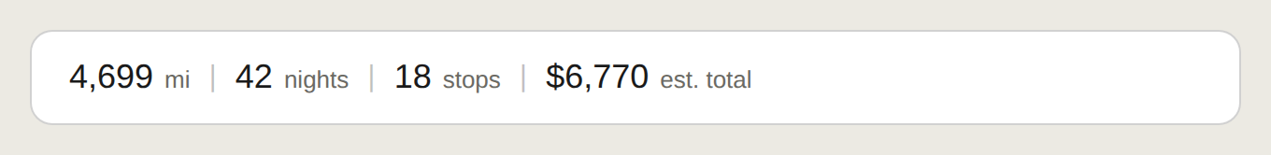
Final “Trip at a Glance” strip — all four stats on one line, numbers ~18px with their unit beside each, thin dividers, roughly a fifth of the previous height.

Build
- Compact strip: numbers drop from ~38px to ~18px, unit label inline beside each value, separated by thin vertical dividers, all on one row.
- Reduced height: padding shrinks (~28px → ~14px vertical) so the strip is ~one-fifth its current height.
- Label: drop the “Trip at a Glance” heading label (self-explanatory at this size; can be kept as a tiny caption if preferred). Keep “est. total” on the dollar figure.

Guardrails
DONE WHEN: The stats bar is a slim one-line strip with all four values, no longer dominating the top of the page.

Block 11 · Drive day card
Context: The drive-day itinerary card on TripSummaryPage.
Goal: Fix the hierarchy (destination was buried), calm the gold book button, bookend the day with matching START/ARRIVE labels.
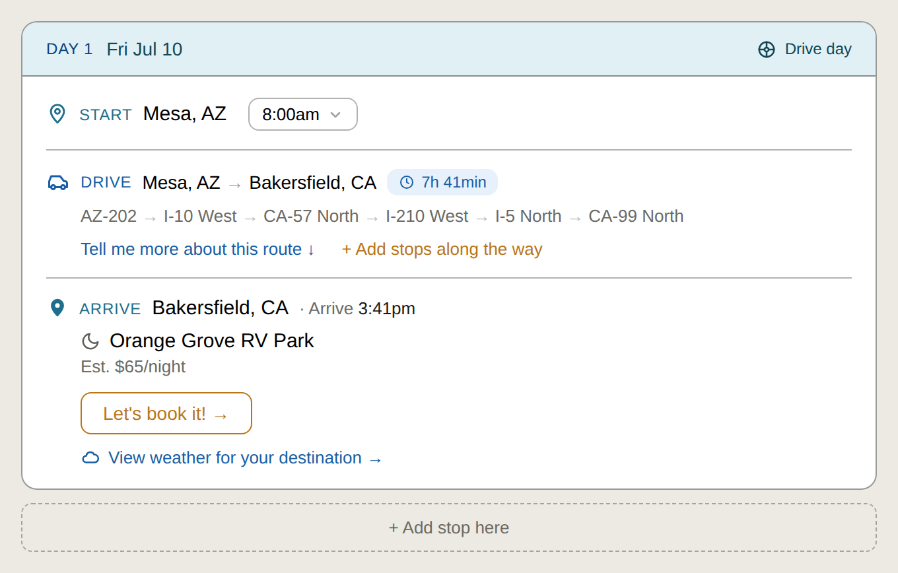
Final drive-day card: pale-blue activity header, consolidated DRIVE line, strengthened borders, START/ARRIVE bookends, bold campground name with moon, estimated rate, gold-OUTLINE book button, weather link.

Build
- Day header tint: the “Day 1 · Fri Jul 10” header gets a pale RV-blue fill (#E0F0F4) with a small “Drive day” tag at right. Header only — body stays white.
- Consolidated drive line: car icon, “DRIVE,” “Mesa, AZ → Bakersfield, CA,” then the duration chip (7h 41min), all on ONE row.
- Stronger borders: outer card border and the two internal dividers move from faint hairline to a solid ~1px border so the day reads as one unit.
- START / ARRIVE bookends: a new “ARRIVE · Bakersfield, CA · Arrive 3:41pm” row mirrors the existing “START” row (same pin icon, same RV-blue label), sitting directly above the campground.
- Bold name + moon: campground name bold with the moon icon inline beside it (moon currently sits as a section-type icon; relocate it next to the name).
- Weather link: replace the bordered weather box with a single “View weather for your destination” link that expands/collapses. Inline temps are intentionally dropped from the collapsed state.
- Remove “Early departure”: delete the “Early departure” text next to the rate.
- Calmer book button: “Let’s book it!” changes from solid-gold fill to a gold OUTLINE button (gold border + text, transparent fill) so it doesn’t blow the gold budget repeated down a long trip.

Guardrails
- Do not touch: the highway route description line (AZ-202 → I-10 West …) and the “Tell me more about this route” link. Leave both as is.
DONE WHEN: A drive-day card matches the mockup: tinted header, one-line drive, clear borders, START/ARRIVE pair, bold campground + moon, weather link, outline book button, no “Early departure.”

Block 12 · Stay day card — visual treatment
Context: The multi-night stay card on TripSummaryPage. (The activity-model change is Block 15.)
Goal: Apply the same card styling as the drive day, adapted to a stay.
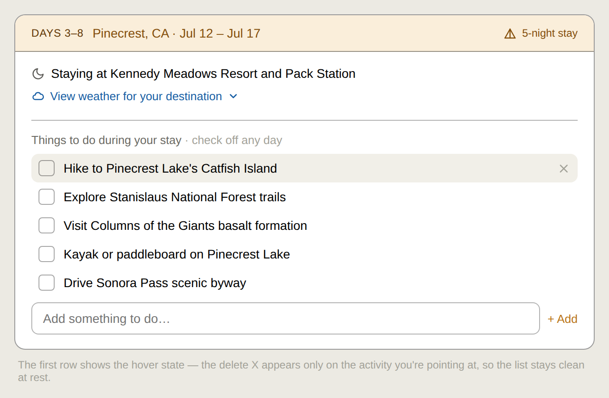
Final stay-day card: pale-gold activity header, bold resort name with moon, weather link, single “Things to do during your stay” menu (Block 15 covers the data side), hover-reveal delete on activities.

Build
- Day header tint: the “Days 3–8 · Pinecrest, CA · Jul 12–Jul 17” header gets a pale amber/gold fill (#FAEEDA) with a “5-night stay” tag at right. Header only — body white.
- Bold resort + moon: “Staying at Kennedy Meadows Resort and Pack Station” — resort name bold, moon icon inline.
- Weather link: same expandable “View weather for your destination” link as the drive day.
- Hover-reveal delete: each activity gets a delete × that appears only on hover (the row pointed at) — no column of ×’s. On mobile, surface via an edit affordance or swipe.

Guardrails
DONE WHEN: A stay card matches the mockup styling: gold header, bold resort + moon, weather link, and activities with hover-reveal delete.

PHASE 4 — BEHAVIOR

Block 13 · Estimate → actual rate on the drive/stay card
Context: The booking flow + the itinerary card rate display.
Goal: Show the campground rate as an estimate before booking, and the actual entered rate after booking.

Build
- Before booking: before booking, show “Est. $65/night.”
- After booking: drop “Est.” and show the ACTUAL rate the user entered in the booking modal (e.g. “$72/night”), plus nights and site #. Replace the gold-outline button with a calm pine-green “Booked · conf #” indicator and an “Edit booking” link.

Guardrails
DONE WHEN: An unbooked stop shows “Est. $X/night”; after booking with a different rate, the card shows the actual rate + booked indicator, no “Est.”

PHASE 5 — AI / DATA (DO LAST)
These touch AI generation and data shape — the riskiest work, deliberately last. Block 15 ends with the trip wipe.

Block 14 · Memberships — fix toggle, capture at signup, per-stop AI flow
Context: Membership cards (Profile/onboarding) + the planning AI + the built itinerary.
Goal: Make memberships actually work: fix the broken toggle, capture them at signup, and surface them as a per-stop post-build choice.
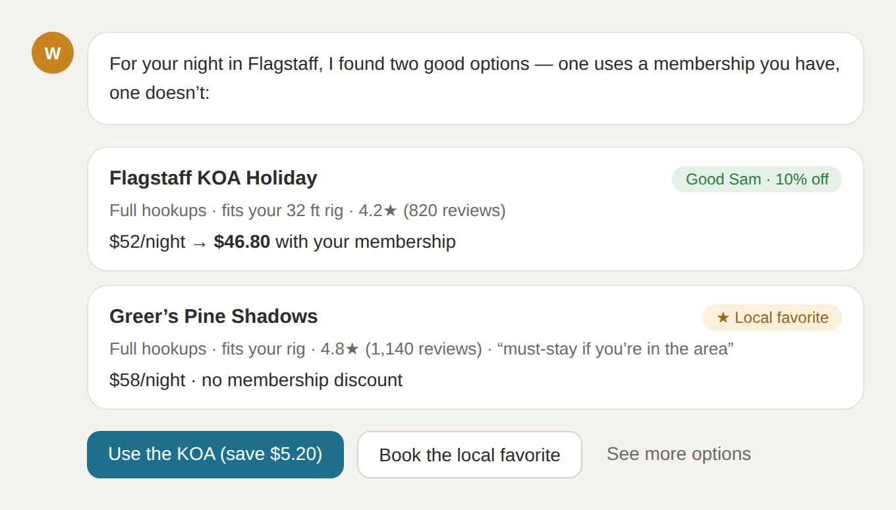
Membership AI choice card (opens on “Review options”): the membership option with savings beside a higher-rated non-member option, with one-tap buttons. Memberships inform, never hard-lock.
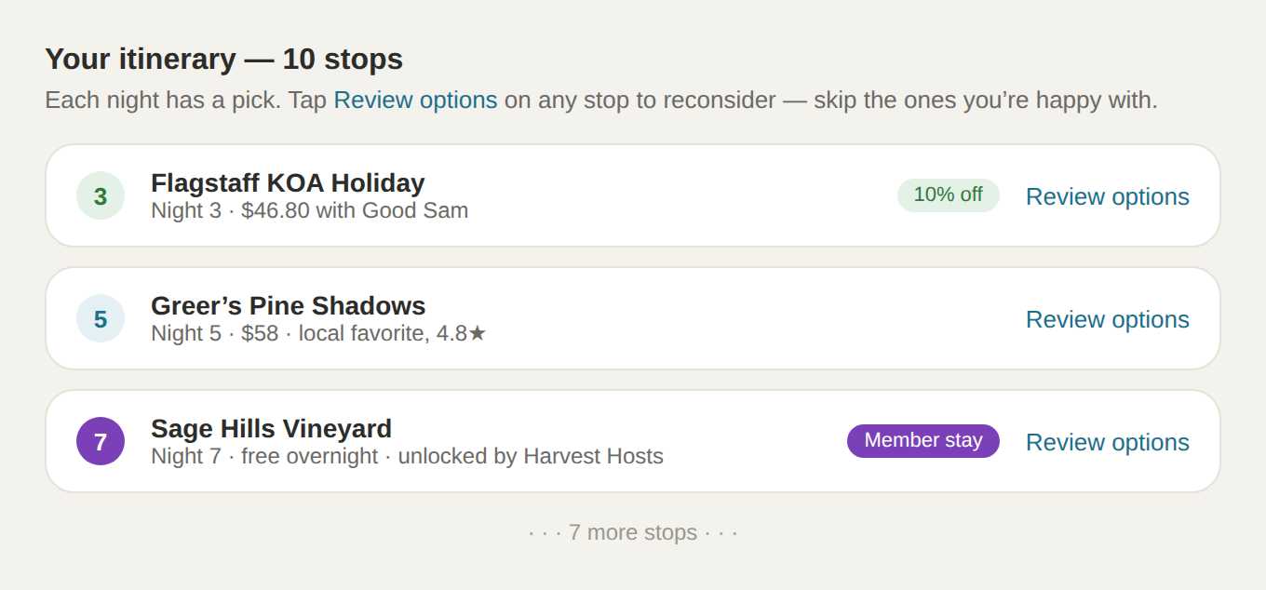
Per-stop review on the built itinerary: the itinerary is built first with smart defaults; each stop has “Review options.” Night 3 = discount membership (savings), Night 7 = network membership (a stay unlocked by Harvest Hosts).

Build
- Bug — cards don’t toggle: the card radio-circle implies it toggles, but clicking doesn’t persist. Backend already supports it — MembershipUpdateSchema (hardened May 1) allowlists isActive and autoApply; the UI just isn’t writing. Wire select/deselect to persist isActive via PUT /me/memberships/:id; confirm where autoApply is set.
- Capture at signup: add a “Got any of these memberships?” step to signup/onboarding, with “Skip for now.” Today memberships live only in the profile and aren’t surfaced at signup, so the feature stays dormant.
- AI weighting: memberships INFORM, never HARD-LOCK. Discount memberships (Good Sam, Escapees, FMCA) — the AI MENTIONS savings when they apply; barely changes which sites are suggested. Network memberships (Thousand Trails, Harvest Hosts, Boondockers Welcome, Coast to Coast) — the AI PROACTIVELY SURFACES the unlocked places. No up-front “do you want me to favor memberships?” question.
- Per-stop choice flow (locked): the conversational “X or Y” choice is a POST-BUILD review pass, not a pre-build gauntlet. AI builds the full itinerary with smart per-stop defaults; each stop shows a “Review options” link; tapping it opens the side-by-side choice card for THAT stop; selecting updates the stop and RETURNS to the list. Why post-build: a 10-stop trip would force 10 serial decisions before the user sees anything AND would bloat the build step — worsening the known token-limit truncation failure where the itinerary JSON gets cut off and the Build button never appears.
- Optional control: a per-membership “auto-apply” toggle on the Memberships page (existing autoApply field), default OFF (surface-and-choose). Lets a die-hard member say “always apply my Good Sam discount.”

Guardrails
DONE WHEN: Membership cards toggle and persist; signup offers membership capture; the built itinerary shows per-stop “Review options” opening the side-by-side choice card; auto-apply defaults OFF.

Block 15 · Stay-day Model B — one shared activity menu (+ trip wipe)
Context: The itinerary generation (AI) + the stay-card data shape + the DB.
Goal: Replace the repeated per-day activity lists on a multi-night stay with ONE shared activity menu, and migrate by wiping disposable test trips.

Build
- AI generation change: today the planner emits the SAME activities copied across each date of a stay (e.g. six identical lists for six days), which reads as filler. Change itinerary generation to produce ONE de-duplicated activity set per multi-night stay, not a per-day repeat. The stay-card UI from Block 12 is already built for this shape.
- Data shape: the stay card shows a single “Things to do during your stay” menu (checkboxes + “Add something to do”), no per-date sub-headers — the date range lives in the card header.

Guardrails
DONE WHEN: A freshly created multi-night stay shows one shared activity menu (no per-day repeats), and old trips have been wiped at the DB level after deploy.

Recorded assumptions
Stated for confirmation; none are blockers:
- Combined length = rig length + vehicle length, ignoring hitch gap / overlap.
- Dimensions remain in feet to one decimal (existing step=“0.1” inputs).
- Towing direction is derived from rig type, never chosen manually.
- Ad-hoc trip vehicles aren’t saved to the profile; assume the rig’s normal towing direction.
- Custom interests cap at 40 characters.
- Membership auto-apply defaults OFF (surface-and-choose).
- “Plan a new trip” CTA on the Dashboard routes to Home (the canvas), since Home is now where trips begin.
- Mockup images are re-renders of the in-session designs; small styling/icon differences from the chat preview are cosmetic. Real UI uses actual characters / proper entities, never raw escape codes.
Martini AI Media LLC | DBA Roamready.ai | Arizona | May 21, 2026

